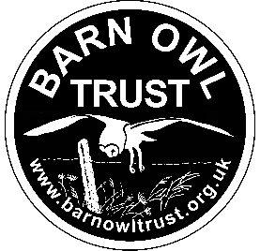
Barn Owl Trust Job Application Form:
Administrative Assistant
Please complete this form and email it to info@barnowltrust.org.uk
1. HOW DID YOU HEAR ABOUT THIS VACANCY?

2. YOUR PERSONAL DETAILS
Any preferred title:  Pronouns:  Surname:  First names:  Address: |  |  |  | Work telephone:  May we ring you at work? Yes | No  Home telephone:  Mobile telephone:  E-mail address:
3. PRESENT EMPLOYMENT (or if now unemployed, details of last employment):
Name and Address of Employer: |  |  |  |  | Job Title:  Present Salary:  From (month/year):  To (month/year):  May we contact your current/last employer?  Yes | No
Please give a brief description of your position, your responsibilities, and key achievements:
(Continue on a separate sheet if necessary)

Reason for leaving:

What notice period do you have to give (if applicable)?
4. EDUCATION AND QUALIFICATIONS - Please give details of your education and the qualifications you have obtained:

Schools/Colleges/University etc: |  | From:  (month/year) |  | To:  (month/year) |  |  | Qualifications obtained and grades
Details of any further qualifications obtained, or relevant courses attended, including dates:

Driving
Do you hold a full driving licence? Yes | No
Do you have any endorsements on your licence? (Please provide details) Yes | No

5. PHYSICAL ABILITY
Are you happy to work at a computer screen for the majority of a working day? Yes | No

6. EMPLOYMENT HISTORY - Please give details of your previous employment over the past ten years (starting from the most recent):
Name of Employer | From:  (month/year) |  | To:  (month/year) |  |  | Salary: |  | Job title, description of the post and reason for leaving:

7. SKILLS AND KNOWLEDGE:

Please say ‘yes’ to all that apply
- Excellent communication abilities (written and verbal)
- High level of adaptability and multi-tasking
- Organisational skills
- Ability to work on your own initiative but happy to be part of the team
- Being customer focussed
- Good time management
- Attention to details and resourcefulness
- Problem-solving skills
- Foundational IT skills
- Are familiar with Microsoft Office, in particular Word, Excel, Outlook and Access
- Email management and sending emails
- Diary management (in Outlook)
- Graphic Design skills (e.g. InDesign or Photoshop)

You may want to provide more detail about your skills and knowledge in Section 8 (Additional Relevant Information).

8. ADDITIONAL RELEVANT INFORMATION
Please set out any additional information that you think will demonstrate your ability to succeed in this role and how you meet the person specification. In particular, we would like to hear about your recent administrative experience, what skills you can bring to the Admin team, that you know and care about the mission of the Barn Owl Trust and conservation as a whole, and why we should interview you for this role.

9. REFERENCES - Employment related
Please give the names and contact details of two people to whom we may apply for a reference (one of these should be your current/most recent employer):
Reference 1 | Reference 2
Name:  Address:  Email:  Telephone Number:  Relationship to Candidate: | Name:  Address:  Email:  Telephone Number:  Relationship to Candidate:
May we contact your referees following a successful interview and conditional offer of employment?
Yes | No

10. Are you available on the interview date? Yes | No

11. If invited to interview, are there any adjustments that are required? Yes | No
If yes, please give details:

12. Have you previously applied for a position with the Barn Owl Trust? Yes | No
If yes, please give details:

13. Do you have any unspent criminal convictions? Yes | No

14. Do you have any restrictions on your right to work in the UK? Yes | No
Under Section 8 of the Immigration Act we are required to check all employees are eligible to work in the UK. Please confirm that, if offered a position, which of the following documents you would be prepared to supply and allow us to make a copy of:
• UK Birth Certificate
• Registration or Naturalisation Certificate
• Work Permit issued by Work Permits UK
• Home Office issued letter indicating permission for indefinite stay in the UK with no restrictions
• P45/P60 from previous employer
• National Insurance Card
• UK Residence Permit form a EEAA state
• Home Office Application Registration card permitting employment
• Passport (current)

Equality, Diversity and Inclusivity
We consider applicants for all positions without regard to age, sex, sexual orientation, pregnancy or maternity, race, ethnicity, nationality, religion or belief, gender identity expression or reassignment, relationship status, martial status and civil partnership, caring responsibilities, trade union activities or political beliefs or any other grounds.
DECLARATION – please read this carefully before signing the application

☐ I agree that any offer of employment is subject to satisfactory references and checks (if required) and a probationary period.

☐ I confirm that the information provided in this application form and all the documents required are complete and correct and that any untrue or misleading information will give my employer the right to terminate any employment contract offered.

☐ If I am appointed, I agree that this form will form part of my Contract of Employment and will be held on my personal records.

Signed:
(Typed signature is acceptable)

Print Name:

Date:

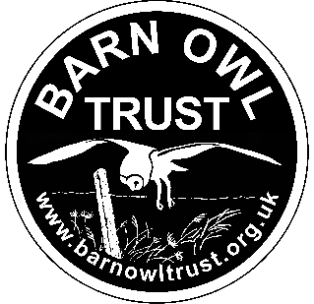

Please email your completed form to info@barnowltrust.org.uk

Attention for the Office Manager

